Intercity Bus Reservation System

1.Abstract:
The Intercity Bus Reservation System is a Java-based application designed to make bus ticket booking and seat management simple and efficient. The system allows users to view available buses, routes, fares, check seat availability, and reserve seats. It also calculates the total fare and provides discounts based on the number of passengers.
The project demonstrates important Java programming concepts such as data types, operators, conditional statements, iterative statements, switch-case, methods, 1D arrays, and 2D arrays. This project helps understand how basic Java concepts can be combined to develop a practical real-world application.

2.Project Objectives:
- To develop a simple Intercity Bus Reservation System using Java.
- To allow users to view buses, routes, fares, and seat availability.
- To provide an easy method for booking and reserving bus seats.
- To calculate the total ticket fare based on the number of passengers.
- To implement basic discount and booking validation.
- To demonstrate Java concepts such as data types, operators, conditional statements, loops, switch-case, methods, 1D arrays, and 2D arrays.
- To understand how Java programming concepts can be applied to a real-world reservation system.
3.Advantages & Disadvantages:
Advantages:
- Easy to use – Simple menu-driven system for booking tickets.
- Saves time – Makes seat reservation faster than manual booking.
- Seat management – Shows available and reserved seats.
- Fare calculation – Automatically calculates the total ticket cost.
- Reduces errors – Minimizes mistakes in seat and fare calculations.
- Demonstrates Java concepts – Uses data types, operators, loops, methods, arrays, and switch-case.
Disadvantages:
- No database – Booking information is not permanently stored.
- Basic interface – The system works through the console and has no graphical interface.
- Limited bus details – Only predefined buses and routes are available.
- No online payment – Payment functionality is not included.
- Single-user system – Multiple users cannot access the system simultaneously.
- No cancellation feature – Users cannot cancel or modify bookings.
4.Implementation Details:
Programming Tools Used:
- Java
- JDK (Java Development Kit)
- IDE / Text Editor
- Scanner Class for user input
Java Concepts Used:
- Data Types and Variables
- Operators
- Conditional Statements (if-else)
- Iterative Statements (for, while)
- Switch-Case
- Methods
- 1D Arrays
- 2D Arrays

Main Modules:
- Bus Details Module – Displays buses, routes, and fares.
- Seat Management Module – Checks and reserves seats.
- Booking Module – Handles passenger booking.
- Fare Calculation Module – Calculates total fare and discount.
- Menu Module – Provides different system options.
5.Java Code:
import java.util.Scanner;

class IntercityBusReservation {

// Method to display available buses
static void displayBuses(String[] busNames, String[] routes, double[] fares) {
System.out.println("\n========== AVAILABLE BUSES ==========");

for (int i = 0; i < busNames.length; i++) {
System.out.println((i + 1) + ". " + busNames[i]
+ " | Route: " + routes[i]
+ " | Fare: Rs." + fares[i]);
}
}

// Method to display seat layout
static void displaySeats(int[][] seats) {
System.out.println("\n========== SEAT LAYOUT ==========");

for (int i = 0; i < seats.length; i++) {
for (int j = 0; j < seats[i].length; j++) {

if (seats[i][j] == 0)
System.out.print("[A] ");
else
System.out.print("[X] ");
}
System.out.println();
}

System.out.println("A = Available X = Reserved");
}

// Method to count available seats
static int availableSeats(int[][] seats) {
int count = 0;

for (int i = 0; i < seats.length; i++) {
for (int j = 0; j < seats[i].length; j++) {
if (seats[i][j] == 0) {
count++;
}
}
}

return count;
}

// Method to calculate fare
static double calculateFare(double fare, int passengers) {
double total = fare * passengers;

// Discount using conditional statement
if (passengers >= 4) {
total = total - (total * 0.10);
}

return total;
}

// Method to reserve seats
static void reserveSeats(int[][] seats, Scanner sc, int passengers) {

for (int p = 1; p <= passengers; p++) {

boolean validSeat = false;

while (!validSeat) {

System.out.print("Enter seat row (1-5) for passenger "
+ p + ": ");
int row = sc.nextInt();

System.out.print("Enter seat column (1-4): ");
int column = sc.nextInt();

// Conditional operators
if (row >= 1 && row <= 5 &&
column >= 1 && column <= 4) {

if (seats[row - 1][column - 1] == 0) {

seats[row - 1][column - 1] = 1;
System.out.println("Seat reserved successfully!");
validSeat = true;

} else {
System.out.println("Seat already reserved!");
}

} else {
System.out.println("Invalid seat number!");
}
}
}
}

public static void main(String[] args) {

Scanner sc = new Scanner(System.in);

// Data types
int choice;
int busChoice;
int passengers;
double totalFare;
String name;

// 1D Arrays
String[] busNames = {
"Express 101",
"Super Fast 202",
"City Rider 303"
};

String[] routes = {
"Hyderabad - Vijayawada",
"Hyderabad - Bangalore",
"Hyderabad - Chennai"
};

double[] fares = {
500.0,
800.0,
900.0
};

// 2D Array
// 0 = Available
// 1 = Reserved
int[][] seats = new int[5][4];

System.out.println("========================================");
System.out.println(" INTERCITY BUS RESERVATION SYSTEM");
System.out.println("========================================");

System.out.print("Enter passenger name: ");
name = sc.nextLine();

// Iterative statement
boolean running = true;

while (running) {

System.out.println("\n========== MAIN MENU ==========");
System.out.println("1. Display Buses");
System.out.println("2. Display Seat Layout");
System.out.println("3. Book Ticket");
System.out.println("4. Check Available Seats");
System.out.println("5. Exit");

System.out.print("Enter your choice: ");
choice = sc.nextInt();

// Switch-case
switch (choice) {

case 1:
displayBuses(busNames, routes, fares);
break;

case 2:
displaySeats(seats);
break;

case 3:

displayBuses(busNames, routes, fares);

System.out.print("\nSelect bus: ");
busChoice = sc.nextInt();

// Conditional statement
if (busChoice < 1 || busChoice > busNames.length) {
System.out.println("Invalid bus choice!");
break;
}

System.out.print("Enter number of passengers: ");
passengers = sc.nextInt();

// Operators
if (passengers <= 0) {
System.out.println("Number of passengers must be greater than 0.");
break;
}

// Check seat availability
int available = availableSeats(seats);

if (passengers > available) {
System.out.println("Only " + available
+ " seats are available.");
break;
}

// Reserve seats
reserveSeats(seats, sc, passengers);

// Calculate total fare
totalFare = calculateFare(
fares[busChoice - 1],
passengers
);

System.out.println("\n========== TICKET ==========");
System.out.println("Passenger Name : " + name);
System.out.println("Bus : " + busNames[busChoice - 1]);
System.out.println("Route : " + routes[busChoice - 1]);
System.out.println("Passengers : " + passengers);
System.out.println("Total Fare : Rs." + totalFare);

if (passengers >= 4) {
System.out.println("Discount : 10%");
} else {
System.out.println("Discount : None");
}

System.out.println("Booking Status : CONFIRMED");
break;

case 4:
System.out.println("\nAvailable seats: "
+ availableSeats(seats));
break;

case 5:
System.out.println("\nThank you for using the");
System.out.println("Intercity Bus Reservation System!");
running = false;
break;

default:
System.out.println("Invalid choice! Please try again.");
}
}

sc.close();
}
}

6.output:
CASE1:
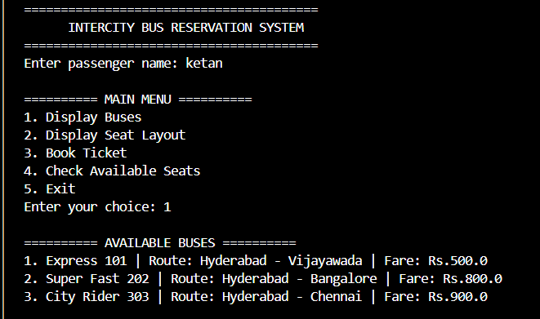
CASE2:
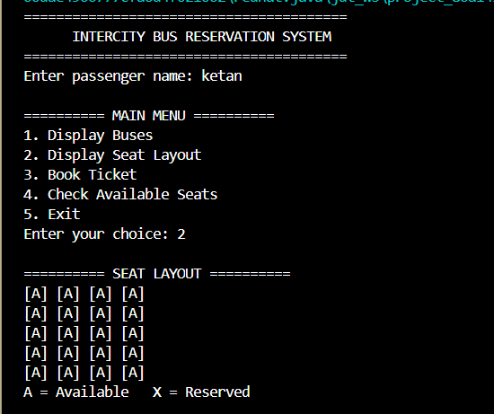

CASE3:
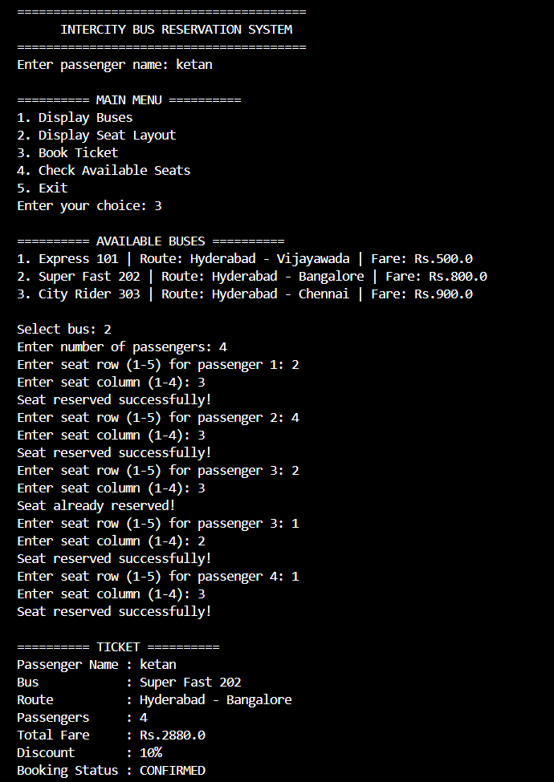

CASE4:
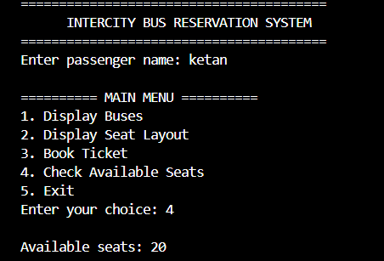
CASE5:
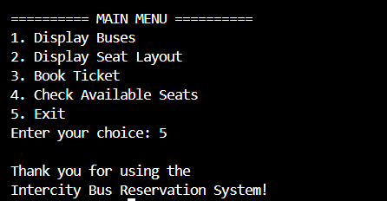
7.Conclusion:
The Intercity Bus Reservation System successfully demonstrates how Java programming concepts can be used to develop a simple real-world application. The system allows users to view bus details, check seat availability, reserve seats, and calculate fares. Through this project, concepts such as data types, operators, conditional statements, loops, switch-case, methods, 1D arrays, and 2D arrays are practically implemented. Overall, the project provides a simple and efficient way to understand the basics of Java programming and reservation systems.

8.Future Work
- Add a database to permanently store passenger and booking details.
- Develop a graphical user interface (GUI) for easier usage.
- Add online payment functionality.
- Include ticket cancellation and modification options.
- Add more buses, routes, and seat types.
- Provide booking confirmation and digital tickets.
- Develop a web or mobile application for online reservations.

